Why a Culture of Sponsorship? 2
What does it mean for managers? 3
What does it mean for all colleagues? 5
Testimonials 6
Supporting your Sponsorship Journey 8

What is a culture of Sponsorship?

A culture of Sponsorship is where all colleagues, especially managers and leaders, are active in sponsoring staff on their journey from career aspirations to achieving career-related goals.

Sponsorship can mean many different things to different people. Imagine there’s a door you want to step through. Sponsorship is when someone doesn’t just show you the door or even open it. Sponsorship is about actively helping you step through it to reach the other side.
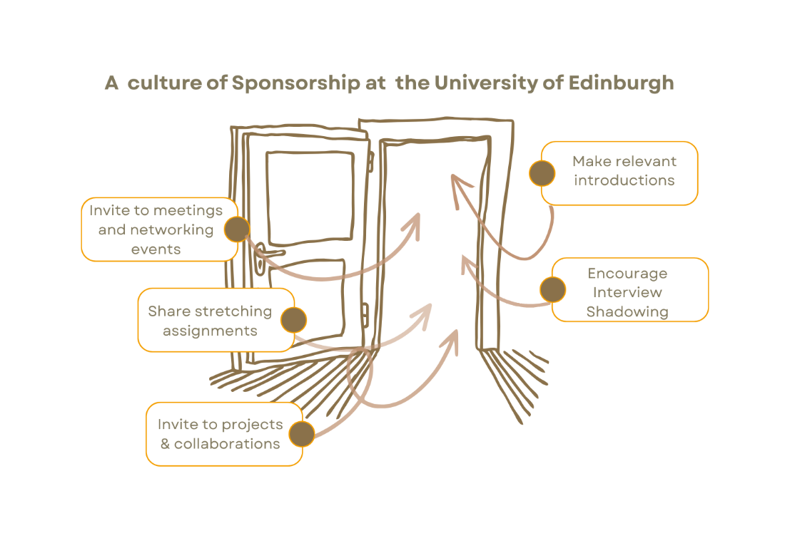

This guide is designed to support a fair, transparent, and purposeful culture of sponsorship at the University of Edinburgh. It is intended to inform, not prescribe, as sponsorship is not a programme or a promise; it is a set of behaviours which all staff can demonstrate.

We will develop this culture of sponsorship through:

- Identifying and inviting colleagues to engage with a diverse set of skills, networks and stretching opportunities.
- Actively supporting and engaging with colleagues in their development journey, empowering them to achieve their aspirations.
- -Mainstreaming these Principles of Sponsorship into everyday work and interactions.
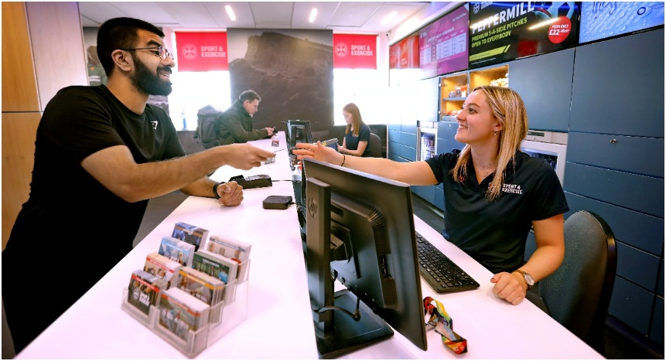

What does it mean for leaders and managers?

Leaders and managers play a crucial role in fostering a culture of sponsorship in others and within themselves. These roles can greatly impact the behaviours, culture and actions of this within and out with their teams, areas and peers.
Leaders and managers are perfectly placed to sponsor colleagues with time, space, opportunity, connections and encouragement to harness the talent that exists right across the University.

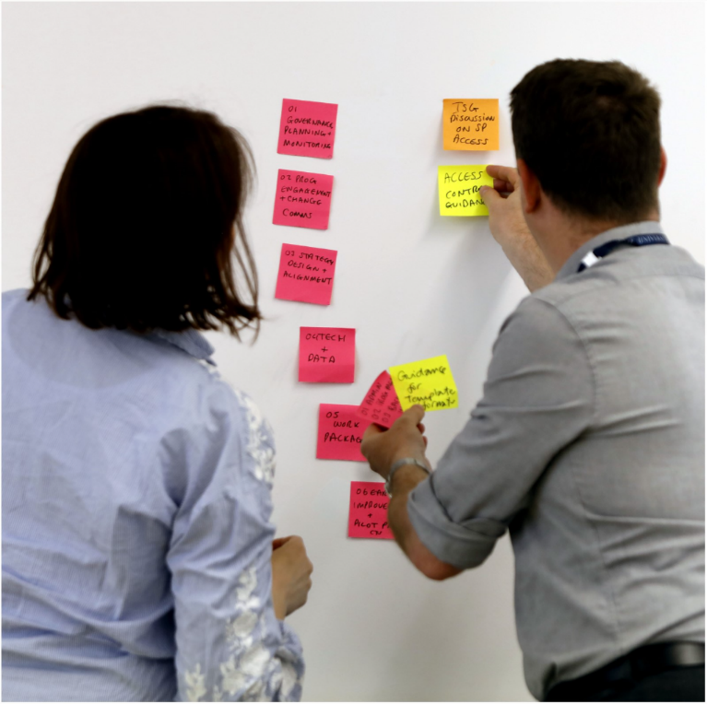
- Understand your teams’ skills: To effectively sponsor, and foster sponsorship, you need to understand what skills your team has and what they want/need to develop. You can do this in a variety of ways from direct conversations, through to more structured team activities. It is particularly powerful when leaders and managers actively identify potential and directly look to grow that through sponsorship.

- Identify goals: Ensuring colleagues feel comfortable enough to discuss their aims and aspirations is a foundation of an effective culture of sponsorship. This enables you to seek out opportunities that will allow colleagues to explore these, for example, putting them in a project outside the team. Speaking about your own journey, whether based at the university or not, can encourage others to do the same.

- Connect Colleagues: Actively encourage and support colleagues to connect with each other. These could be peers or from grades above or below that will expand someone’s network and access to opportunities. The saying ‘it’s not what you know, it’s who you know’ is grounded in the concept that people trust and engage more with people they know.

- Demystifying the next steps: Understanding, and then acquiring/demonstrating the skill-set required to move from one grade or role to the next, can often be challenging, and for many will appear somewhat hidden. After all, how are you supposed to know what happens if you have not seen or experienced it yourself? It’s your role, as a leader or manager embedding sponsorship, to proactively encourage and support aspiring team members to equip themselves to take that next step - this could be through giving them stretch opportunities, role/interview shadowing opportunities, access to secondments and much more.

- Embedding Sponsorship Schools and Departments may have ongoing plans and initiatives that lend themselves to Sponsorship. You have the freedom to apply these guide and ideas to your existing plans. Some areas may take inspiration from these principles and build a local sponsorship programme.

- Annual Reviews Unlock Sponsorship: Acknowledging and celebrating colleagues’ achievements is the foundation of a good annual review, but a strong annual review will also be a great opportunity to evaluate career paths, skills and aspirations. Here you can really embed sponsorship, not just discuss goals and aims, but really explore what you can do to help them achieve their goal - how will you open that door for them?

- For resources to support conversations around Annual Review, please visit the conversations hub.

- Don’t forget about yourself! Sponsoring is for all, remember that as a valued member of our community you should also consider your own career plans and ambitions. Why not take a minute to read (link to Sponsorship for individuals).
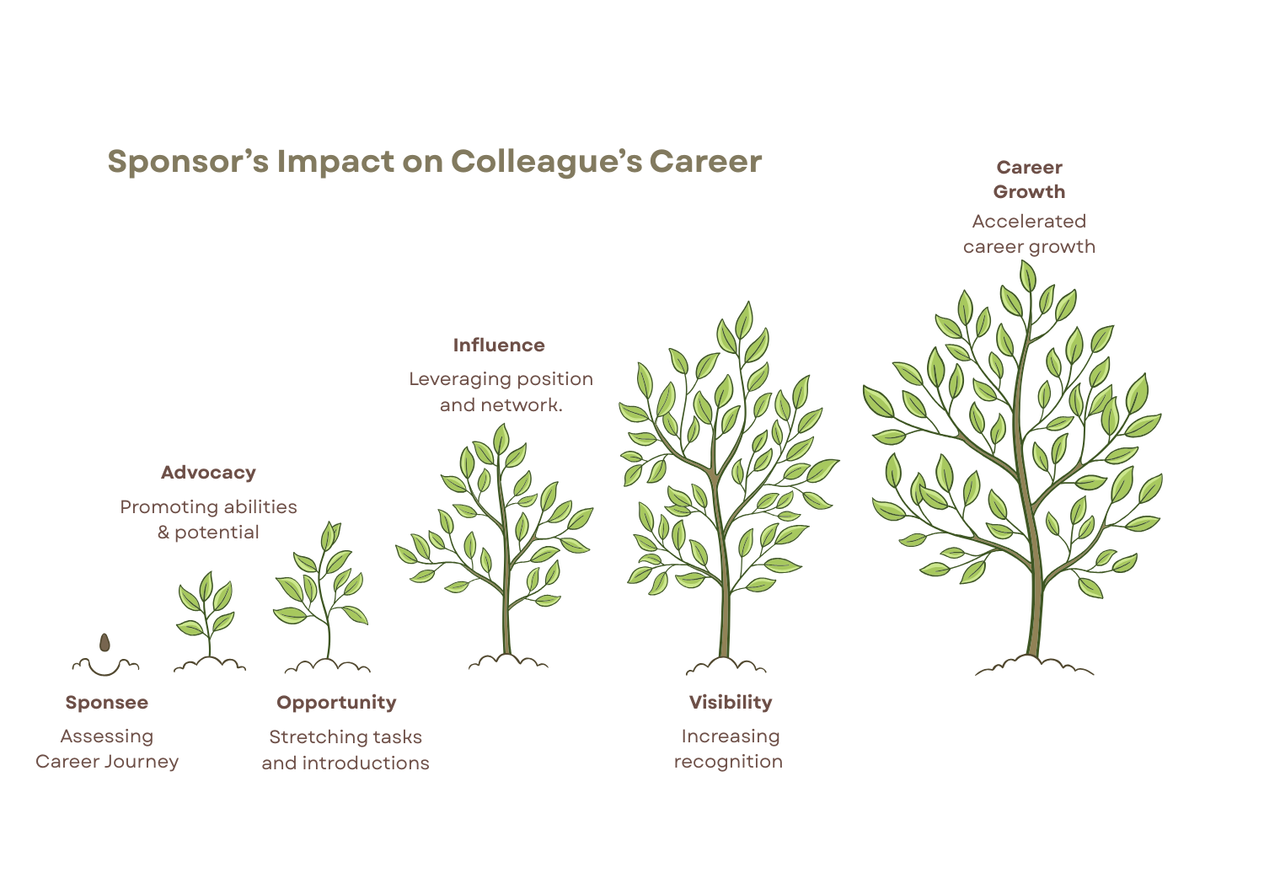

What does it mean for all colleagues?



A culture of sponsorship isn’t something that is created purely by leaders and managers. Every colleague can benefit from and actively contribute to really bringing this culture to life.

- Be open about your aspirations: Take time to reflect on what you want to learn, experience, or achieve in your career. Be honest about your goals. Share them with your manager and colleagues so they understand how they can support and sponsor you. If you are open about yours, others will be open about theirs and you can find ways to foster active sponsorship throughout teams.

- Connect near and far: Develop your own, and help others develop their connections across teams and the wider University. Engaging with others helps you learn from different perspectives and makes it easier for others to recognise your strengths and potential. Engaging across the institution will allow you to discover people who can connect to opportunities. Being more visible will make it easier for others to know and sponsor you, valuing your strengths and potential.

- Actively seek learning opportunities: Look for opportunities to stretch your skills, whether through projects, secondments, shadowing, or informal learning. Reach out for support to get connected, don’t wait for opportunities to come to you. If you’ve seen or heard something that would be great for a colleague, send them the information, make that introduction/suggestion and help them grow
- Sponsor each other: Knowing your colleague’s strengths empowers and enables you to make connections with, and for, them. You might make an important introduction for your colleague that could open doors to collaboration and learning opportunities - and they might do the same for you. It may be that you/they have current or future projects which could allow you to demonstrate, learn or grow their skills and connections. Before doing this, make sure you have open communication with their line manager to ensure capacity and support.

Testimonials

Professional Services Testimonial

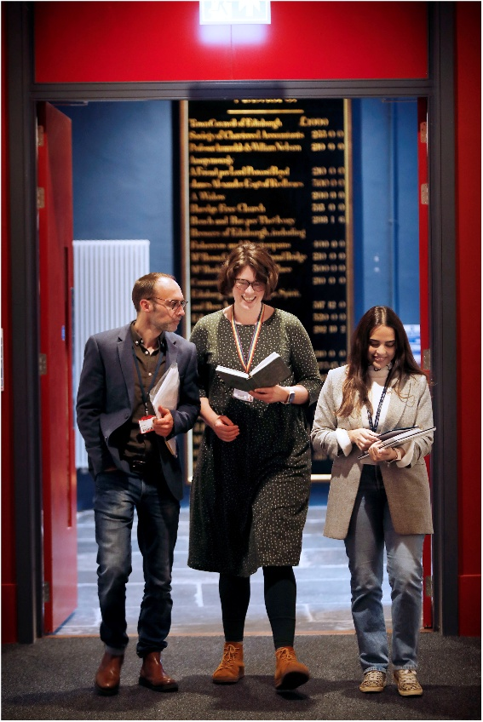
“After three years working in Student Administration, I felt that I was ready for a different challenge. I spoke to my line manager and expressed interest in a change to Wellbeing. Through our conversations, my manager invited me to observe relevant meetings with Wellbeing and neighboring teams. Those meetings gave me precise information about the skills and experiences I needed to achieve my goals. My manager’s introductions proved crucial in making key contacts throughout the University. I spent the next six months shadowing projects, as well as taking part in some online learning. Eventually I collaborated on a project, which demonstrated the skills I had learnt. Two months later a job opening came up in the wellbeing team and I am delighted to have gotten the role. Looking back, I see that having that relevant experience made all the difference! I have been in job interviews where I found myself really stretching my experience to suit a role that perhaps I did not fully understand. Having collaborated with the team made a world of difference”

Academic testimonial

“My PhD supervisor more than just supervised my research, she pushed me to develop further. She was able to highlight my strengths whilst helping me decode the university and UK academia. This was incredibly helpful as an international researcher. My supervisor made a key collaborative introduction that completely shifted my career and exposed me to large data management in my field. Soon I was being asked to collaborate on various papers in this field.

Getting the right advice and support from my sponsor, concentrated my efforts in collaborations and projects that maximised my efforts and got me closer to securing a permanent position.

An early career researcher outside our centre, gave me some advice and some support which was gold dust for when I was interviewing. He invested time in me and put me in front of some great skills sessions until the right opportunity came along. I continue collaborating with him and his institution even now I’m somewhere else. I recently secured funding for a project, and I plan to ‘pay it forward. and offer as much help, advice and support as my supervisor and the ECR did to me as it’s made all the difference”

Team Testimonial

“When I came back to work after a long illness, I really needed more than just to be directed to the policies available and to be reintroduced to my team. So much had changed across the University and contacts I had before now were gone or somewhere else. My first sponsor was a peer who understood the connections between our team and other departments and actively put me in front of the right people to make sure I could really deliver.

Once I felt confident speaking to my manager about the challenges I faced at work, those honest conversations led to a deeper understanding of my strengths and aspirations.

My manager then really stepped into more of a sponsor role and worked with me to highlight learning that was available to support my development, and then a great project that put some of that into practice. Now I feel like a very different person than when I first came back. I have collaborated in exciting projects with neighboring teams, and I feel ready to apply for roles that I previously wouldn’t have even looked at.”


Supporting your Sponsorship Journey

Explore career paths and learning suggestions by clicking the different links (open in a new window)

Institute for Academic Staff Development
Career Management for Early Career Academic Researchers
Professional Services Development
Career Development Support for Technicians.

You may also be interested in the Talent and Development Courses or Interview Shadowing (opens in a new window)

