**Guidance for NHS Research Passports**

The Research Passport system and associated procedures have been developed in parallel with national arrangements for obtaining permission from NHS organisations to undertake research.

The Research Passport is an application form which enables Higher Education Institute employers to share pre-engagement information about their researchers with NHS organisations hosting the researcher's activity. The Research Passport (once approved) is valid for a duration of 3 years and allows for the issue of an Honorary Research contract or a Letter of Access.

To ensure that Research passports are processed as quickly as possible once they are submitted to the NHS, the form needs to be completed as accurately as possible.

The following guidance notes should be read in conjunction with the Research Passport Guidance Notes, Application form and the Research Passport Appendix page available at: <https://www.ed.ac.uk/human-resources/about/in-colleges/medicine-vet-medicine/nhs-honorary-cover/nhs-honorary-cover>

**CHECKLIST FOR COMPLETING A RESEARCH PASSPORT**

Please send completed Research Passports and Appendix pages to [Employment.Checks@ed.ac.uk](mailto:Employment.Checks@ed.ac.uk)

**Section 1 – Details of Researcher**

|  |  |
| --- | --- |
| * Question 1 – Enter name and contact details |  |
| * Question 2 – Enter basic identity details |  |
| * Question 3 – Enter details of any professional registration |  |
| * Question 4 – Enter details about substantive employer (University of Edinburgh) |  |

**Section 2 – Details of Research (Question 5)**

|  |  |
| --- | --- |
| * Type of Research Passport: Ensure the correct type of Research passport has been chosen – either a Project Specific one, or a Multi-Project[1] (see footnote) |  |
| * For Project Specific Research Passports the details of the study should then be completed in Section 2. For “Multi-Project” Research Passports the details of each study should be completed as a separate appendix page (one appendix page for each study) |  |
| * Project Title: Ensure the full exact study title is included, and **include the R&D number of the study (or NRS**, **IRAS or REC number where appropriate) in brackets**. Forms without a relevant number will be rejected. |  |
| * Project Start Date & End Date: Ensure project start and end dates are completed accurately. For “project-specific” Research Passports, the project start date should be when the researcher plans to be involved in the study at the first site, and the end date should be when the researcher plans to complete their involvement in the study at the last site. For a “multi-project” Research Passport the project start date (on each appendix) should be when the researcher plans to be involved in that study at the first site. The end date should be when their involvement in that study will finish) |  |
| * Proposed Start & End Date of 3 Year Research Passport: The Research Passport start date should be the planned start date of involvement at the first study site, or the date the Research passport is submitted, whichever is later. The Research Passport end date should be 3 years from the Research Passport start date. |  |
| * NHS Organisation & Department: List the NHS Boards, and departments within those boards, where research will be undertaken |  |
| * Proposed Research Activities: Describe very briefly the activities that will be undertaken e.g. taking blood, accessing NHS identifiable patient data, conducting cognitive testing, conducting interviews with NHS patients |  |
| * Manager in NHS Organisation: Insert name of the person who will manage, supervise, or be responsible for the researcher’s conduct in each NHS Board – ideally the PI. **The same individual must complete and sign Section 4**. |  |
| **General Checks:** | |
| * Ensure all the studies listed are currently still ‘live’ and have not ended? |  |
| * Check that individual is listed as a researcher on the each study application. If not please ensure they are added before the Research passport is submitted to HR |  |
| * Ensure appendix page(s) have been included if necessary (these should always be completed when the researcher is on more than 1 study, section 2 is full, or if there are additional studies to be added. *See How to Use an Appendix page at the end of this document |  |
| * Email the Manager(s) in the NHS organisation(s) to make them aware that the NHS R&D department will be contacting them via email to confirm details relating to the individual’s Research passport application and that they must respond to this email |  |

**Section 3 – Declaration by Researcher**

|  |  |
| --- | --- |
| * Question 6 – answer questions relating to any previous Honorary Research contracts and if they have ever been revoked |  |
| * Researcher must sign and date this section to allow the information in the Research passport to be shared with other NHS organisations, otherwise checks that have already been carried out may need to be repeated. |  |

**Section 4 – Suitability of Researcher (must be completed by Researchers line manager)**

|  |  |
| --- | --- |
| * Question 7a – regulated activity relates to where the Researcher would be undertaking regulated work (e.g. clinical care of NHS patients such as taking blood) under the Protecting Vulnerable Groups (PVG) scheme. When a PVG level Disclosure is required this would be for regulated work. When a level 2 Disclosure is required (e.g. interviews with patients) this would not be regulated work. The [NHS Honorary Cover Table](https://www.ed.ac.uk/sites/default/files/atoms/files/nhs_honorary_cover_table_v11.pdf) can be used to determine whether the duties fall into the definition of regulated work, and if PVG is therefore required. |  |
| * Question 7b – must be signed and dated by the line manager and all contact details completed. **The line manager must be the same person named in** **Section 2**, who is the manager in the relevant department in which the work is being carried out, ideally the PI. |  |

**Section 5 – Pre-engagement Check**

|  |
| --- |
| * Leave blank for HR to complete (send to [medstaffing@ed.ac.uk](mailto:medstaffing@ed.ac.uk)) |

**Section 6 –Instructions to applicants**

|  |  |
| --- | --- |
| * A signed and dated CV must be provided and crossed off here |  |
| * A copy of PVG or Level 2 Disclosure Certificate will be submitted from HR if required but should be crossed off here if applicable |  |
| * Evidence of Occupational Health clearance will be submitted from HR if required but should be crossed off here if applicable |  |
| * Write the number of Appendices included or cross N/A if none are submitted |  |

**Section 7**

|  |
| --- |
| * Leave blank for NHS to complete (HR will submit the application) |

**Section 8**

|  |
| --- |
| * Leave blank for NHS to complete (HR will submit the application) |

**APPLYING FOR AN EXTENSION**

* If the researcher holds a **Research Passport that is less than 3 years old**, a completed copy of the Appendix page detailing the new information should be submitted. An example of the Appendix page is shown below, stating the Appendix page number, the reason for the amendment to the Research Passport, and the old and new end dates. Disclosure and occupational health checks do not need to be re-completed.
* If a previous **Research Passport is more than 3 years old** or the **Researcher does not hold an existing Research Passport,** then a new Research passport application form must be completed.

New PVG/Disclosure and Occupational Health checks will need to be completed with a new Research Passport application (if required for the study) in the following circumstances:

* Previous Occupational Health clearance is more than 3 years old.
* Previous Level 2 Disclosure certificate is more than 6 months old.
* If a PVG level Disclosure has been previously completed for the University, this does not need to be re-completed regardless of the length of time since the certificate was issued.

**HOW TO USE AN APPENDIX PAGE**

* An Appendix page should be used for Multi-Project Research Passports where a separate page should be completed for each study
* They should also be used for any changes that are required, such as change in employment status, change of end date of involvement in a study, changing from a Project Specific to a Multi-Project Research Passport, change of name etc.
* Researcher must ensure that all NHS organisations are informed of the changes.
* See Section 2 above for assistance in completing an appendix page.

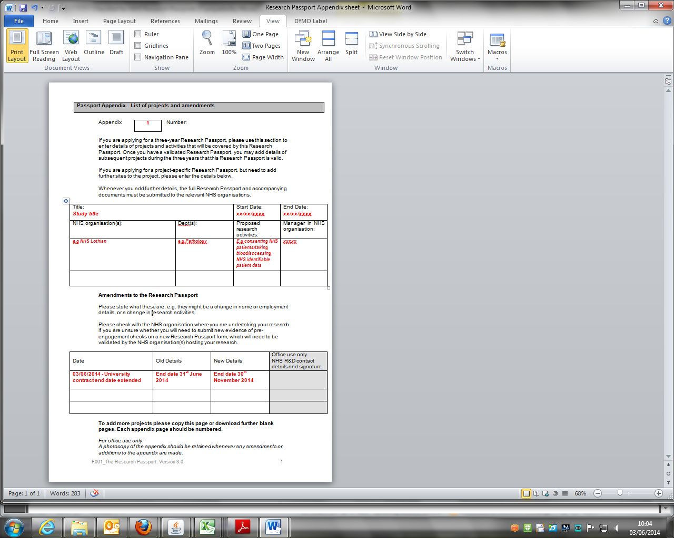**Example of Research Passport Appendix Page for Extensions**

1. There are two types of Research Passport: a project-specific and a multi-project Research Passport:

   1. The project-specific Research Passport is for researchers who will be involved with only one study/project over the duration of the three year Research Passport.
   2. The multi-project Research Passport is for researchers who will be working on a number of studies over the course of the three year Research Passport and have an ongoing research portfolio. As many Appendix pages can be added as required but please number each Appendix page.

  