How to use these toolkits

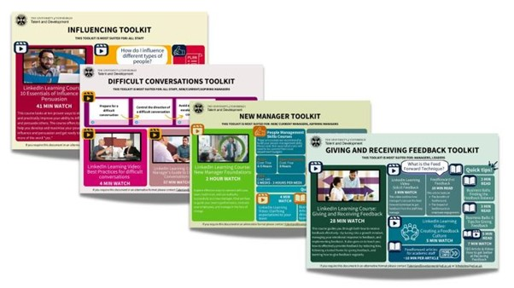

**How do I access the resources?**

All resources are hyperlinked. If you hover over the resource you want to access, you should be able to click it and it will take you to that resource.

**What are these toolkits for?**

These toolkits are designed to be self-development tools that you can dip in and out of when you please. They are a tool you can use to help you take ownership over your professional development.

**Where do I start?**

There is no order that these toolkits should be completed – it is up to you to pick resources that you feel are most relevant to you! Feel free to take your time going through the LinkedIn Learning Courses, some are quite long so it is best to break them up.

**Who are these toolkits for?**

Each toolkit will outline who it is most relevant for e.g., new managers, aspiring managers, leaders, all staff.